**[Type the company address]**

08

**Fall**

Course Work Cover Sheet - The School of Computing

**Author’s Name:** Kevin Shewan (110014571)

Scott Reid (110014567)

Heather Ellis (100009618)

Euan Luke

Patrick Cowan

**Module Code:** AC31007

**Assignment Title :**  Assignment 1

**Date Submitted:** 12.10.12

**Date Due to be submitted:** 12.10.12

|  |  |
| --- | --- |
| Your course work may be used by The School of Computing for demonstration purposes with other classes and/or members of the public, unless you indicate otherwise. Tick the box at the right if you do *not* wish your work to be used in this way. | ❒ |

I certify that this assignment represents all my own work and that no parts of it have been copied and that no collusion has taken place with any other person. I have also read and understood The School of Computing’s regulations as regards course work and I certify that this course work was performed according to those regulations.

I certify that any disks submitted with this assignment have been virus checked and have no viruses on them.

Signed: ………….…..Kevin ……………. ………….…..Scott…………….

………….…..Euan……………. ………….…..Patrick …………….

………….…..Heather …………….

Table of Contents

Important Information 2

Conversations with the client 2

Initial meeting with the client (19.9.12 & 21.9.12) 4

User stories and Acceptance Tests 6

Product Backlog 9

Sprint Backlog 11

Design Mockups 12

Evidence of conversations with client and the Scrum Master resolutions 13

Usability Score and Survey 15

Acceptance Tests Approved in Sprint Review 16

# Important Information

Our user stories were stored on my.myagilityboard.com with the user details:

**Username:** unhandledexceptions

**Password:** group5

You can see how we used the business value and effort to give us an actual value for the user story, as agreed with the client.

We held scrums every day and each day there was a different Scrum Master which meant that the rest of us could focus on other tasks and didn’t have to worry about the issues for the day.

# Conversations with the client

**Date:** 12.9.12

**Discussed**:

* Had initial meeting with client and asked her questions to give more details on her initial requests. See below.
* The order of priority of each request was selected by the client and the user stories are now ranked in order of priority.

**Date:** 19.9.12

**Discussed:**

* The user stories were created and approved. Some changes needed to be made and were during the meeting.
* The wording of two user stories needed to be improved and one user story was an acceptance test for another. This was added as an acceptance test for the user story numbered 5.

**Date:** 21.9.12

**Discussed**:

* The design mockups were agreed with the client for the screens. These can be seen below. She seemed pleased and liked the designs, no further changes were required.
* The business value and effort was attached to the user stories. The team has now added the effort expected and worked out the actual value of the user story.

**Date:** 24.9.12

**Discussed:**

* Shares in alphabetical order
* Total shares’ values moved up higher
* Rocket or plummet in colour and with arrows
* Plummets and rockets layered down screen.
* Best: how much it has made relative to it’s original price  
  --performance as percentage of price  
  Worst: Ranking
* ‘Goldy’ Yellow arrow to side for run

**Date:** 3.10.12

**Discussed:**

* The acceptance tests were written up and approved by the client in a final check before the sprint began.
* The team proposed two user stories and one as a potential with the client approval and understanding that the third one was only a small maybe.
* The client understood that this selection was final for this sprint and that no more items could be added until the next sprint.

**Date:** 10.10.12

**Discussed**:

* The sprint review went well except that one share price was wrong. It was realised that in a last minute update there had ben a change of characters which meant that it was reading in the American prices rather than the British prices. This was fixed and signed off on.
* All acceptance tests were passed and signed off by the client who seemed pleased that all her requirements were met.
* The new user stories were then selected based on the team’s velocity and the acceptance tests have been approved by the client however a couple of changes are to be made and sent back for a final review.

# Initial meeting with the client (19.9.12 & 21.9.12)

1. **(5)An estimate of how much her whole portfolio is worth**
   1. How often does she want it displayed?
      1. *Only when she goes to that section of app*
   2. How does she want it to be displayed?
      1. *Just a single value and name*
2. **(4)An estimate of how much each set of shares is worth**
   1. How often does she want an update?
      1. *When she opens up the app*
   2. What currency does she want the app to have?
      1. *Local (GB£) based on what it is currently valued at*
   3. How is an estimate made?
      1. *Through working out what the current value of the shares are worth at that moment*
3. **(7)To know how much money she has lost or gained in the week**
   1. How does she want this displayed?
      1. *Just a single statement*
   2. How often does she want this to be updated?
      1. *Every time she opens the app*
4. **(2)An alert to be raised if any of the share prices plummet or rocket**
   1. What is a rocket?
      1. *10% increase*
   2. What is a plummet?
      1. *20% decrease*
   3. What market are we using?
      1. *London Stock Exchange*
   4. What type of alert does she want?
      1. *Badge icon and a noise when she opens the app*
   5. What details does she want shown? Price opening, Change in value? Money made/lost?
      1. *How much it has changed by only*
5. **(8)An alert to be raised if there is a run on any of her shares**
   1. What is a ‘run’?
      1. *When more than 10% of the shares are sold*
   2. What types of alerts does she want?
      1. *A notoficiation at the top of the screen*
6. **(3)A summary of the best and worst performing shares of the week**
   1. Overall or hers personally?
      1. *Just hers – no login required as personal app*
   2. What type of display does she want?
      1. *Just a single value for the best and a single value for the worst*
   3. Does she want just a snapshot of a particular time period, ie the end of the week?
      1. *No – see above*
7. **(6)Information about the weekly high and low for each share**
   1. What is a ‘week’?
      1. *Monday 0800 – Friday 1630*
8. **(1)To see the rise and fall in prices of the shares each day**
   1. How does she want the shares displayed? Graphs? Sections?
      1. *A grid like system*
   2. How often do you want to refresh the app?
      1. *When I open the app*
   3. What share information do you want shown?
      1. *The change in share price, no decimals*

**GUI/Other Questions**

1. **What colour schemes do you want? (Need for colour blind users)**
   1. *Plain and simple, based on share apps already existing*
2. **What type of menu do you want? Logo based, text based or swipe based?**
3. *Liked the scrolling menu*
4. **Do you want a ‘ticker’ on screen to scroll through the updates?**
   1. No, a simple box at the top will be okay
5. **Will you be the only user or will it be a shared app?** 
   1. *Only user*

# User stories and Acceptance Tests

**USER STORY**

Business Value: 90

Effort: 8

Actual value: 11.3

Story points estimated: 9

When is it done: When the raw data matches the Yahoo details on the Yahoo Finance sheet

**As a developer I will be required to research available access to the London stock exchange API’s and develop an integration of this for the project to make a central point of access for all other user story requirements and display this raw data on screen**

**ACCEPTANCE TESTS**

The data for the BP and M&S should be output and provide a correct comparison between the data on the HTC Sensensation and the data online. The label that is displayed should conform to the Mock Up already agreed with the client.

**USER STORY**

Business Value: 100

Effort: 3

Actual value: 33.3

Story points estimated: 8

When is it done: When the total calculated is the same as that calculated manually using Yahoo finance.

**As a user I want a one line display of the total worth of my portfolio to allow ease of access.**

**ACCEPTANCE TESTS**

The design of the page should match the one agreed with the client in the first meeting.

The client should be able to physically calculate the same value as the app outputs by looking at an online version of Yahoo on a laptop.

The total figure should be precise to the nearest pound.

**USER STORY**

Business Value: 90

Effort: 4

Actual value: 22.5

Story points estimated: 6

When is it done: when the value calculated matches that as the online Yahoo Finance

**As a user, I want to view my weekly profit or loss in one line so that at a glance I can see how my shares performed this week.**

**ACCEPTANCE TESTS**

The design should match the mockup that the client already agreed.

The client should be able to calculate whether the weekly profit or loss the shares from the close of day at 1630 the Friday before. This data should be comparable to Yahoo’s finance on a laptop and the data output on the HTC Sensation.

The final figure shown should be rounded to the nearest pound.

**USER STORY**

Business Value: 70

Effort: 4

Actual value: 17.5

Story points estimated: 8

When is it done: When the calculation matches that to the Yahoo Finance site.

**As a user I want the app to give me a current update of what each company's shares are currently worth.**

**ACCEPTANCE TESTS**

The design should match the mockup that the client already agreed.

This data should be comparable to Yahoo’s finance on a laptop and the data output on the HTC Sensation and proven to be correct.

The values shown should include pence.

**USER STORY**

Business Value: 40

Effort: 4

Actual value: 10

Story points estimated: 7

When is it done: When the calculation matches that to the Yahoo Finance site.

**As a user, I want a notification of any shares that there is a run for so that I can be up to date.**

**ACCEPTANCE TESTS**

The design should match the mockup that the client already agreed.

The client should be able to calculate whether a run or plummet has occurred for BP or M&S. This data should be comparable to Yahoo’s finance on a laptop and the data output on the HTC Sensation.

There should be a colour indication and value change direction for the change. A green arrow up should be a rocket and a red arrow down should be a plummet, as agreed in the mock up.

**USER STORY**

Business Value: 30

Effort: 5

Actual value: 6

Story points estimated: 8

When is it done: When the calculation matches that to the Yahoo Finance site.

**As a user I want a notification to alert me when there is a rocket or plummet in my portfolio.**

**ACCEPTANCE TESTS**

The design should match the mockup that the client already agreed.

The client should be able to calculate whether a rocket or plummet has occurred for BP or M&S. This data should be comparable to Yahoo’s finance on a laptop and the data output on the HTC Sensation.

There should be a colour indication of value change up or down. A green arrow up should be a rocket and a red arrow down should be a plummet, as agreed in the mock up.

**USER STORY**

Business Value: 30

Effort: 5

Actual value: 6

Story points estimated: 9

When is it done: When the calculation matches that to the Yahoo Finance site.

**As a user I want a summary of my best and worst performing shares of the week to keep track of my investments.**

**ACCEPTANCE TESTS**

The design should match the mockup that the client already agreed.

The client should be able to calculate the best and worst performing shares of the week from closing time at 1630 on Friday. This data should be comparable to Yahoo’s finance on a laptop and the data output on the HTC Sensation.

The figures should be correct to two decimal points.

# Product Backlog

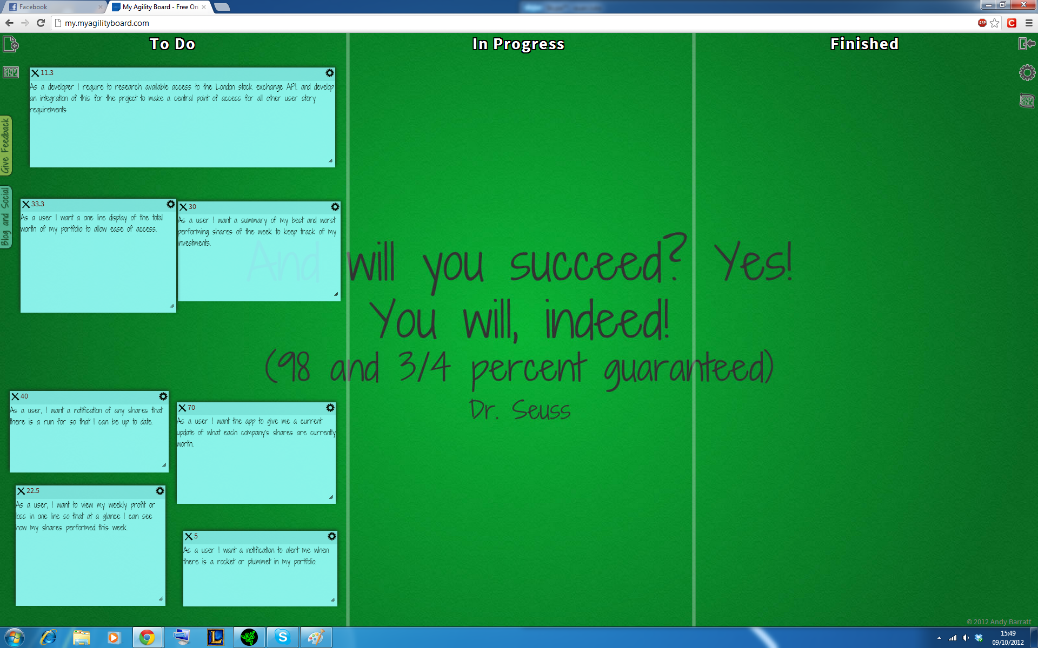

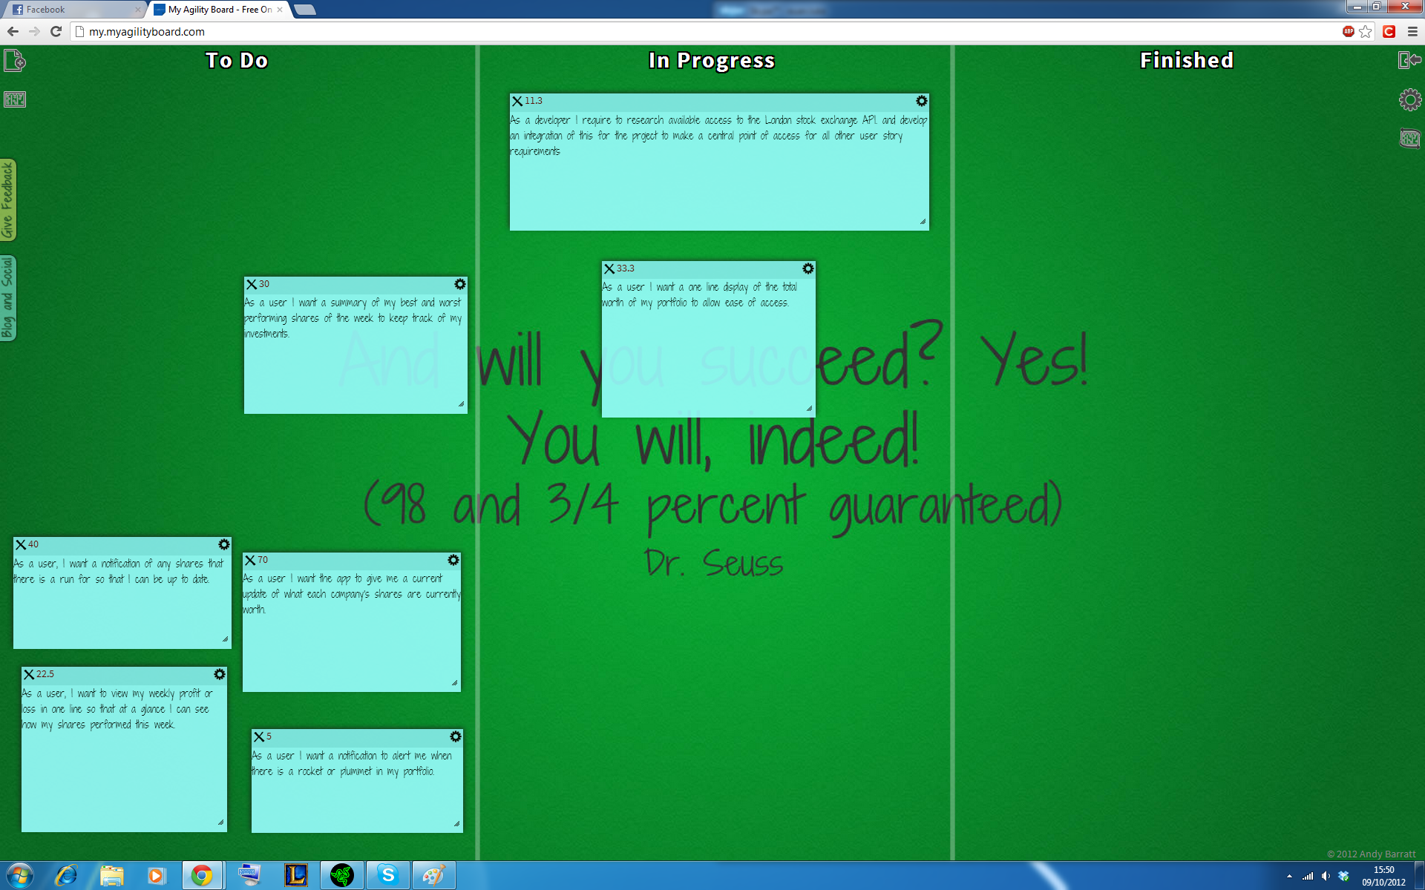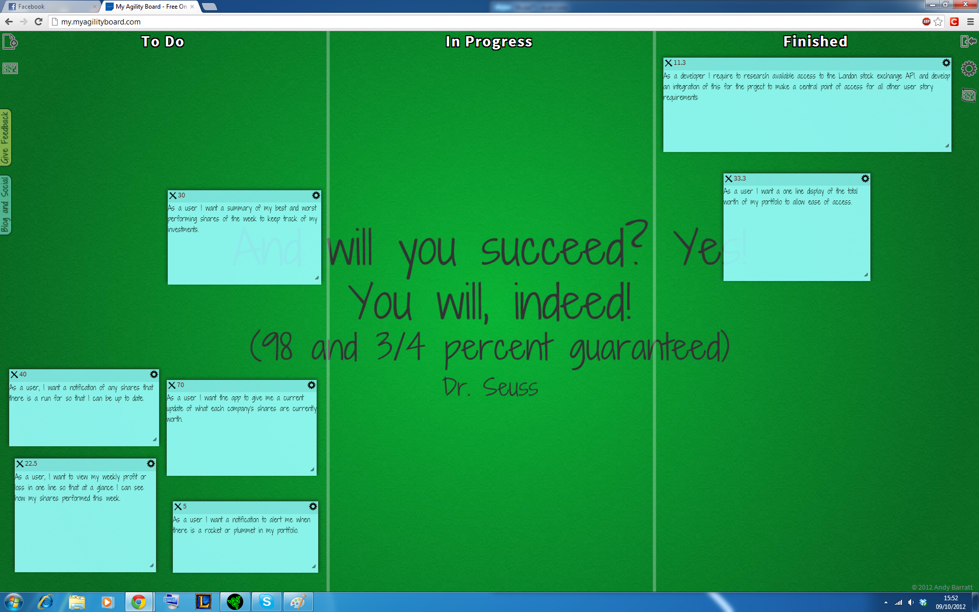

# Sprint Backlog

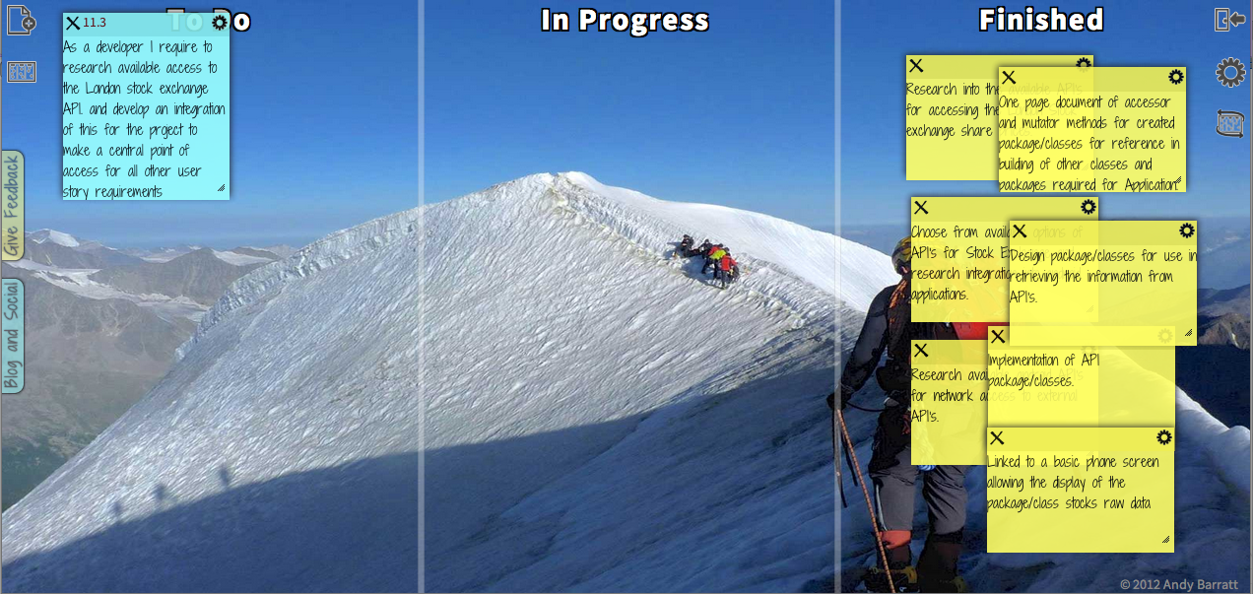

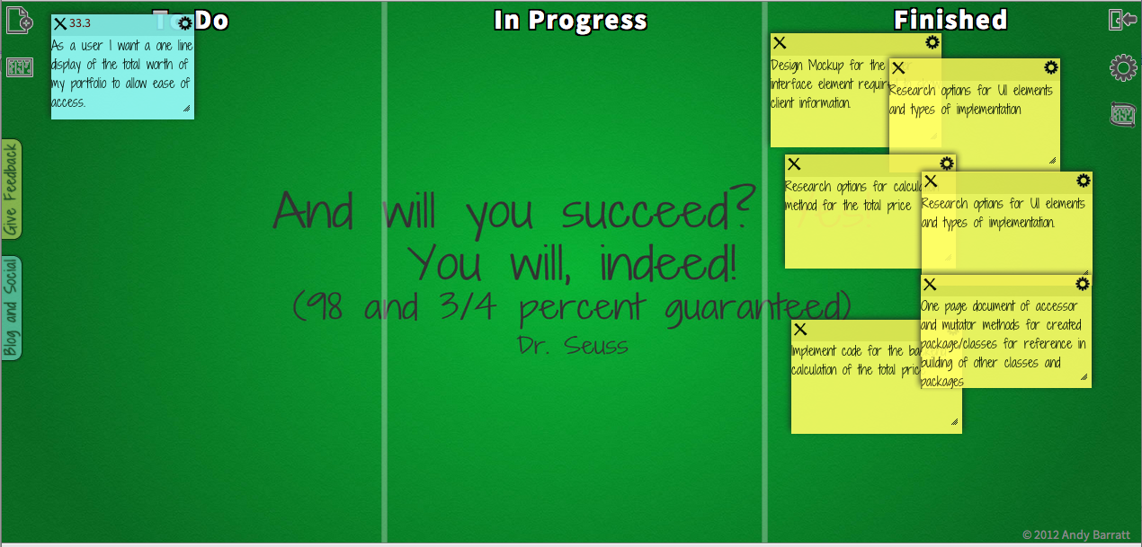

# Design Mockups

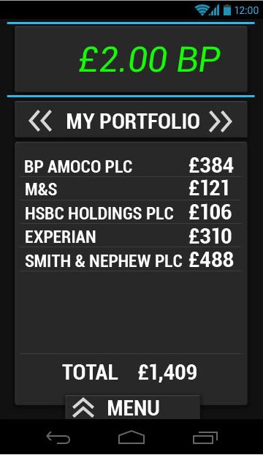 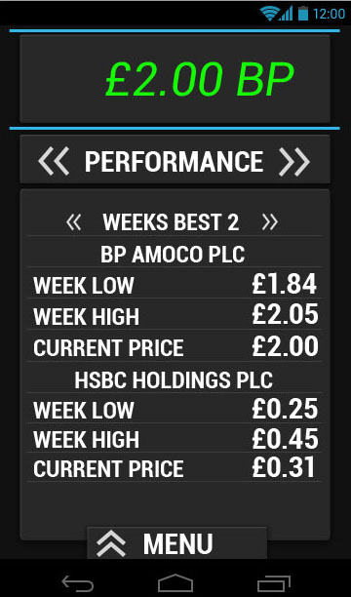

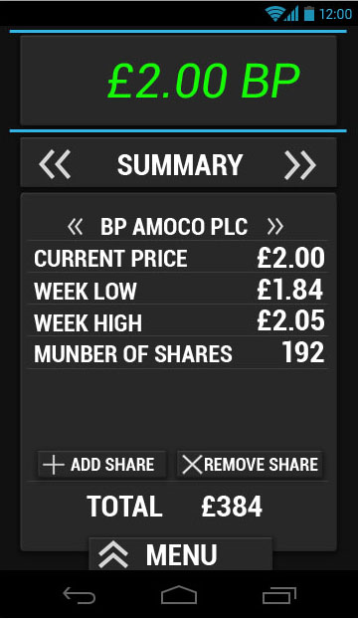 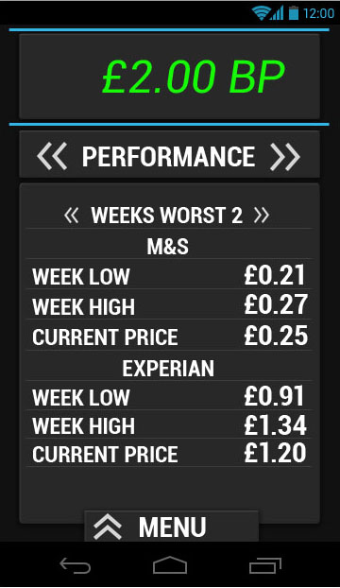

# Evidence of conversations with client and the Scrum Master resolutions

**From:** [jhughes@computing.dundee.ac.uk](mailto:jhughes@computing.dundee.ac.uk) [[jhughes@computing.dundee.ac.uk](mailto:jhughes@computing.dundee.ac.uk)]

**Sent:** 04 October 2012 13:26

**To:** Euan Luke

**Subject:** Re: [spam ?] Re:

Fine, will do.

Janet

Sent using BlackBerry® from Orange

**From:** Euan Luke <[E.Luke@dundee.ac.uk](mailto:E.Luke@dundee.ac.uk)>

**Date:** Thu, 4 Oct 2012 12:06:48 +0000

**To:** [jhughes@computing.dundee.ac.uk](mailto:jhughes@computing.dundee.ac.uk)<[jhughes@computing.dundee.ac.uk](mailto:jhughes@computing.dundee.ac.uk)>

**Subject:** RE: [spam ?] Re:

Janet,

We have booked room 1.06 and were hoping to have the presentation there if that is ok?

Euan

**From:** [jhughes@computing.dundee.ac.uk](mailto:jhughes@computing.dundee.ac.uk) [[jhughes@computing.dundee.ac.uk](mailto:jhughes@computing.dundee.ac.uk)]

**Sent:** 04 October 2012 12:59

**To:** Euan Luke

**Subject:** [spam ?] Re:

Certainly, Euan. Consider it booked. Where shall I meet you?

Janet

Sent using BlackBerry® from Orange

**From:** Euan Luke <[E.Luke@dundee.ac.uk](mailto:E.Luke@dundee.ac.uk)>

**Date:** Thu, 4 Oct 2012 11:37:14 +0000

**To:** Janet Hughes<[j.z.hughes@dundee.ac.uk](mailto:j.z.hughes@dundee.ac.uk)>

**Subject:**

Dear Janet,

As Scrum leader for the group Unhandled Exceptions I am writing to ask if we could have the ten o'clock slot with you next Wednesday ( 10th of October) for our presentation of our working prototype from the first sprint.

Regards,

Euan Luke

**From:** Patrick Cowan

**Sent:** Thursday, October 11, 2012 6:50 PM

**To:** Janet Hughes

**Subject:** Submission

Hi Janet,

    I was scrum leader today and our group had one problem, none of us actually knew how to submit the first assignment tomorrow. Do we have to submit a hard copy to you or do we submit it via blackboard?

Thanks for the help,

    Patrick Cowan

**From:** Janet Hughes [[jhughes@computing.dundee.ac.uk](mailto:jhughes@computing.dundee.ac.uk)]

**Sent:** Tuesday, October 02, 2012 1:29 PM

**To:** Patrick Cowan

**Subject:** RE: Scrum

Hi, team.

1000 meeting is fine tomorrow, yes.

Re the user stories, I have some questions:-

a.       are they presented here in the order you recommend for development?  If so, which one(s) will be done in this first sprint thingy?

b.      What will **I** get from the first one listed?

c.       What’s all that API/accessor/mutator stuff?

d.      The things I most wanted of all (total value of portfolio) isn’t shown – does that mean it can’t be done?

Thanks

Janet

**From:** Patrick Cowan [mailto:p.cowan@[dundee.ac.uk](http://dundee.ac.uk/)]  **Sent:** 01 October 2012 20:47 **To:** Janet Hughes **Subject:** Scrum

Dear Coffee Janet,

As Scrum leader for the group Unhandled Exceptions I am writing to ask if you could find a moment to look over our user stories and acceptance tests and make sure everything we have written is how you want it to be. I would also like to ask if we could have the ten o'clock slot with you on Wednesday during the morning lab to discuss, go over and sign off the acceptance tests which we have produced. I have attached the user stories and acceptance tests with this e-mail.

Regards,

    Patrick Cowan

# Usability Score and Survey

The Usability score was a 85% usability score which the team was quite pleased with and hope to improve on this in the coming sprint.

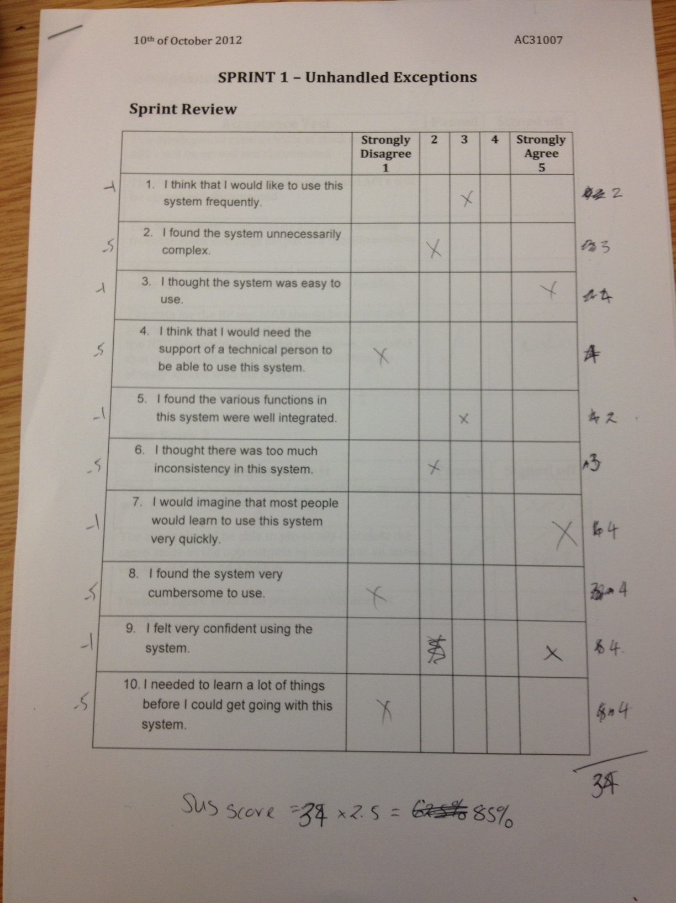

# Acceptance Tests Approved in Sprint Review

